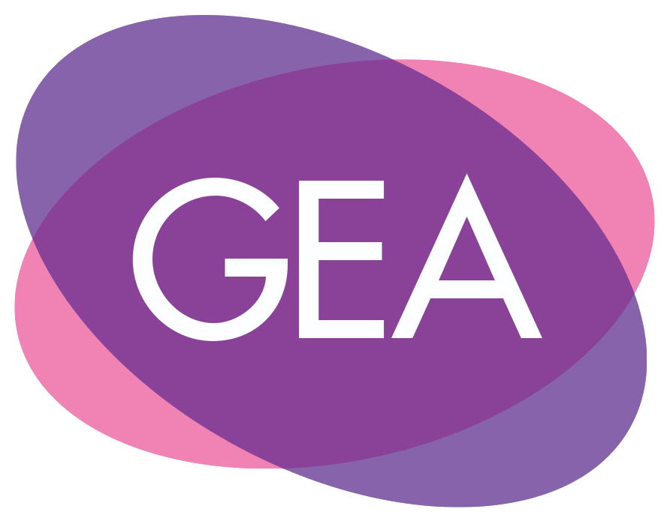

Application for membership to the Gender and Education Association Executive Committee

About You
Your Full Name
Your Organisation/ University/ School
E-mail
Twitter (optional)

Available Roles
Please select the box(es) for the role(s) in which you are interested in applying.
GEA Executive Member Reps
The Executive Member Rep roles that GEA are currently recruiting for include:
BIPoC Member Rep: representing Black, Indigenous, and People of Colour and those from additional underrepresented racial/ethnic identities, including, for example, Gypsy Roma Traveller (GRT) communities.
LGBTQIP2SA+ Member Rep: representing Lesbian, Gay, Bisexual, Transgender, Queer, Intersex, Pansexual, Two-Spirit (2S), Asexual, and those from additional underrepresented gender and sexual identities.
Disabilities Member Rep: representing disabled individuals including those with visible and/or invisible disabilities.
We hope to appoint two Member Reps for each underrepresented group.

Please tell us why you are applying for this role(s)?
Please outline the reasons you would like to join the GEA Executive Committee. Tell us about the key skills and experience you have that will allow you to serve the Gender and Education Association in this specific role. (700 words maximum)
If you are applying for more than one role, please tell us what distinct skills you have for each of the roles.

Equalities Monitoring information
Before submitting your application, please complete this Equality Monitoring Form:
https://forms.gle/QEYae5HBRcaTNaTn6

In order to better shape GEA's work as an international, intersectional feminist charity; to evaluate our activities, initiatives, and events; and to better understand and serve our members, we are asking questions related to: country of current residence, race/ethnicity, gender identity, disability, sexual identity, and pronouns.
Categories have been drawn from standardised sources (such as HESA, Stonewall, and census questions) that do not fully reflect the diversity of possible responses to each question. Please feel free to self-describe where the available categories do not fit with your identities.
Should you wish not to disclose this information, please select ‘prefer not to say’.

It is the policy of GEA to provide equal opportunities without regard to race, religion, national origin, gender, sexual preference, age, or disability.

Agreement and Signature
By submitting this application, I confirm that the facts set forth in it are true and complete. I understand that if I am accepted onto the GEA Executive Committee, any false statements, omissions, or other misrepresentations made by me on this application may result in my immediate dismissal.
Name (printed)
Signature
Date

About GEA
The Gender and Education Association is a volunteer-led international intersectional feminist charity. Since 1997, our community of educators, researchers, activists, leaders, artists, and more have been working to challenge and eradicate gender stereotyping, sexism, and gender inequality within and through education. UK charity number: 1159145

Please apply by completing the Equality Monitoring Form and sending a completed application and your CV to: GenderAndEd@gmail.com

Deadline to apply for the current roles: 14th June 2021
Thank you for completing this application form and for your interest in GEA.

