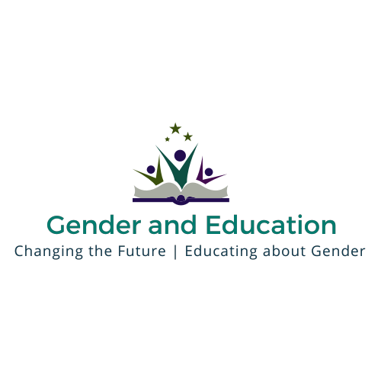

The 11th International Gender and Education Association Biennial Conference
JUNE 2017

CALL FOR PROPOSALS
The Gender and Education Association are pleased to announce that their next international biennial conference will be held in June 2017. The GEA executive committee welcome proposals to host the biennial conference from higher education institutions across national contexts and from conference teams spanning a variety of academic disciplines, theoretical backgrounds and fields.

The deadline for submission will be 28th September 2016.

Your conference proposal should include the following information:
- Details of local organising committee
- Conference theme and proposed dates
- Conference venue, facilities, accommodation
- Outline of the conference, including provisional programme
- Potential keynote speakers
- Details of funding required from GEA and how this would be used
- Additional sources of funding

For further information about GEA conferences and other events, please visit our website at www.genderandeducation.com. To submit a proposal to host the biennial conference and to ask further questions, please contact Dr. Vanita Sundaram at vanita.sundaram@york.ac.uk.

