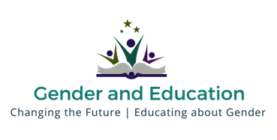
Executive Committee Positions
August 2016

The Gender and Education Association is an international charitable organisation seeking to support the development of, and networking opportunities for, those working in the higher education sector as researchers, writers and practitioners concerned with issues of gender and education. We seek to:
- Produce, promote and disseminate feminist and other critical scholarship on gender and education.
- Raise awareness about international, national and local policies and practices relating to gender and education.
- Create networks to encourage and generate the exchange of information and ideas between academics, practitioners, activists and policy makers.
- Embed within teaching and learning practices a commitment to achieving gender equality.

We are seeking several new executive members to support our work

We would welcome applications from colleagues with an interest in supporting the development of our website and social media presence.

We require that new Executive Committee members are able to attend one annual face-to-face meeting in London. Travel expenses under £150 will be reimbursed. Please bear this in mind when considering whether to apply.
We would like to recruit up to 5 new Executive members.
Process for application
- Announcement of Executive Committee vacancies – 22 February 2016
- Completed applications to be submitted to Teresa Dawkins, GEA Administrator - contactgea2016@gmail.com by 18 March. Please put ‘Application to GEA’ in the subject line of your email.
- The Co-Chairs will review applications by 31 March 2016.
- If there are more than 5 strong applications, GEA members will be invited to vote during April 2016.
- If there are not more than 5 strong applications, the Co-Chairs will present their short-listed candidates to the Executive Committee for a vote.
- New Executive Committee members to be announced during the 1st week of May.

